PREDICTIVE ANALYTICAL MODEL FOR ACADEMIC AND RESEARCH ACTIVITIES : AUTOMATION FOR ENHANCED EFFICIENCY

A Major Project Report Submitted in partial fulfilment of the requirements for the award of the degree of

Bacholors of Technology in

**INFORMATION TECHNOLOGY**

Submitted by

K. PradeepSai (20071A1227)

Under the Guidance of

## Dr G Rajesh Kumar

Associate Professor, Department of IT, VNR VJIET

**Major Project -Phase - II**

**DEPARTMENT OF INFORMATION TECHNOLOGY**

**VALLURUPALLI NAGESWARA RAO VIGNANA JYOTHI INSTITUTE OF ENGINEERING & TECHNOLOGY**

An Autonomous Institute, NAAC Accredited with ‘A++’ Grade, NBA Accredited for CE, EEE, ME, ECE, CSE, EIE, IT B. Tech Courses, Approved by AICTE, New Delhi, Affiliated to JNTUH, Recognized as “College with Potential for Excellence” by UGC

ISO 9001:2015 Certified, QS I GUAGE Diamond Rated

Vignana Jyothi Nagar, Pragathi Nagar, Nizampet (S.O), Hyderabad – 500 090, TS, India

**APRIL 2024**

**VALLURUPALLI NAGESWARA RAO VIGNANA JYOTHI INSTITUTE OF ENGINEERING and TECHNOLOGY**

An Autonomous Institute, NAAC Accredited with ‘A++’ Grade, NBA Accredited for CE, EEE, ME, ECE, CSE, EIE, IT B. Tech Courses, Approved by AICTE, New Delhi, Affiliated to JNTUH, Recognized as “College with Potential for Excellence” by UGC, ISO 9001:2015 Certified, QS I GUAGE Diamond Rated

Vignana Jyothi Nagar, Pragathi Nagar, Nizampet(SO), Hyderabad-500090, TS, India

**DEPARTMENT OF COMPUTER SCIENCE AND ENGINEERING**

**CERTIFICATE**

This is to certify that the project report entitled “**PREDICTIVE ANALYTICAL MODEL FOR ACADEMIC AND RESEARCH ACTIVITES : AUTOMATION FOR ENHANCED EFFICIENCY** ” is a bonafide work done under our supervision and is being submitted by **Mr. K. PradeepSai(20071A1227)** in partial fulfilment for the award of the degree of **Bachelor of Technology** in Information Technology, of the VNRVJIET, Hyderabad during the academic year 2023-2024.

Certified further that to the best of our knowledge the work presented in this thesis has not been submitted to any other University or Institute for the award of any Degree or Diploma.

**Dr G Rajesh Kumar Dr D Srinvasa Rao**

Associate Professor & Project Guide Associate Professor & HOD

Department of IT Department of IT

**External Examiner**

**VALLURUPALLI NAGESWARA RAO VIGNANA JYOTHI INSTITUTE OF ENGINEERING and TECHNOLOGY**

An Autonomous Institute, NAAC Accredited with ‘A++’ Grade, NBA Accredited for CE, EEE, ME, ECE, CSE, EIE, IT B. Tech Courses, Approved by AICTE, New Delhi, Affiliated to JNTUH, Recognized as “College with Potential for Excellence” by UGC, ISO 9001:2015 Certified, QS I GUAGE Diamond Rated

Vignana Jyothi Nagar, Pragathi Nagar, Nizampet(SO), Hyderabad-500090, TS, India

**DEPARTMENT OF COMPUTER SCIENCE AND ENGINEERING**

**DECLARATION**

We declare that the major project work entitled “**PREDICTIVE ANALYTICAL MODEL FOR ACADEMIC AND RESEARCH ACTIVITIES : AUTOMATION FOR ENHANCED EFFICIENCY** ” submitted in the department of Computer Science and Engineering, Vallurupalli Nageswara Rao Vignana Jyothi Institute of Engineering and Technology, Hyderabad, in partial fulfilment of the requirement for the award of the degree of **Bachelor of Technology** in **Information Technology** is a bonafide record of our own work carried out under the supervision of **Dr G Rajesh Kumar, Associate Professor, Department of IT, VNRVJIET.** Also, we declare that the matter embodied in this thesis has not been submitted by us in full or in any part thereof for the award of any degree/diploma of any other institution or university previously.

Place: Hyderabad.

|  |
| --- |
| K. Pradeep Sai  (20071A1227) |

**ACKNOWLEDGEMENT**

We express our deep sense of gratitude to our beloved President, Sri.D. Suresh Babu, VNR Vignana Jyothi Institute of Engineering & Technology for the valuable guidance and for permitting us to carry out this project.

With immense pleasure, we record our deep sense of gratitude to our beloved Principal, Dr.C.D. Naidu, for permitting us to carry out this project.

We express our deep sense of gratitude to our beloved Professor Dr. SRINIVASA RAO DAMMAVALAM, Associate Professor and Head, Department of Information Technology, VNR Vignana Jyothi Institute of Engineering & Technology, Hyderabad-500090 for the valuable guidance and suggestions, keen interest and through encouragement extended throughout the period of project work.

We take immense pleasure to express our deep sense of gratitude to our beloved Guide, Dr. G. Rajesh Kumar, Assistant Professor in Information Technology, VNR Vignana Jyothi Institute of Engineering & Technology, Hyderabad, for his valuable suggestions and rare insights, for constant source of encouragement and inspiration throughout my project work.

We express our thanks to all those who contributed for the successful completion of our project work.

K. Pradeep Sai (20071A1227)

**ABSTRACT**

College teachers may find it difficult to manage the wide range of research resources, such as papers, patents, publications, and journals, in the quickly changing academic environment. Using the power of contemporary technologies, this abstract proposes a novel way to automate the management of these research resources. Our approach makes use of a number of technologies, such as HTML, CSS, JavaScript, ReactJS, MongoDB, and ExpressJS, to expedite the organisation, retrieval, and finding of material.

Our programme is made to provide researchers and college instructors with quick access to research papers that are most pertinent to their chosen topic of study. The ease with which users can use keywords to find relevant content greatly improves the effectiveness of the research process. The days of searching through mountains of paperwork or having trouble finding a certain document in a jumbled digital environment are long gone.

The integration of machine learning (ML) and natural language processing (NLP) algorithms forms the core of our system. Research materials can be retrieved from a database using these state-of-the-art technologies in response to the user's search queries. Our system is able to identify and rank the resources that most closely correspond to the user's demands since it comprehends the context and content of every document.

To sum up, research material management automation has the potential to completely change how academic resources are accessed and used by college professors and researchers. Our solution leverages the capabilities of HTML, CSS, JavaScript, ReactJS, MongoDB, ExpressJS, NLP, and ML to improve the efficiency and effectiveness of the research process. An overview of the bright future of research material management, where technology streamlines and expedites knowledge acquisition, is given in this abstract.

**Table of Contents**

|  |  |
| --- | --- |
| Acknowledgements | 4 |
| Abstract | 5 |
| Abbrevations |  |
| List of Figures |  |
| List of Tables |  |
|  |  |
| Chapter-1: Introduction | 8 |
| 1.1 Problem Statement | 9 |
| 1.2 Objective of the project | 10 |
| 1.3 Scope | 10 |
| 1.4 Project Introduction | 11 |
| 1.5 Thesis Organization | 12 |
| Chapter-2: Literature Survey | 13 |
| Chapter-3: Methodology | 16 |
| 3.1 Existing System | 16 |
| 3.2 Proposed System | 16 |
| 3.3 Advantages of the Proposed System | 17 |
| 3.4 Workflow Diagram | 18 |
| 3.5 Methodology for uploading publications | 18 |
| 3.6 Methodology for publication retrieval | 19 |
| 3.7 Software Requirements | 19 |
| 3.8 Hardware Requirements | 19 |
| Chapter-4: Design | 20 |
| 4.1 Introduction of Input Design  -4.1.1 Objectives for Input Design:  -4.1.2 Introduction to Output Design:  -4.1.3Objectives for Output Design: | 20  20  21  21 |
| 4.2 UML Diagram  -4.2.1 Use Case Diagram  -4.2.2 Class Diagram  -4.2.3 Sequence Diagram  -4.2.4 Activity Diagram | 21  21  24  25  26 |
| Chapter-5: Implementation | 31 |
| 5.1 Datasets Used | 31 |
| 5.2 Experimental setup | 33 |
| Chapter-6: Conclusions | 45 |
| Chapter-7: Future Scope | 46 |
| Chapter-8: References | 47 |
| APPENDIX A: Dataset Descriptions |  |
| APPENDIX B: Source Code |  |
| APPENDIX C: Result Graphs which are not included in main document. |  |

**CHAPTER 1**

**INTRODUCTION**

In fact, the Academia is all about discovering new things and right in the middle of that chain of events are researches: articles, patents, books, and journals. Academic development in colleges specifically is functioned on the fact that instructors and researchers have the capabilities of handling this wealth of knowledge and retrieving them accordingly. It is not simply an issue of convenience. Recognizing the importance of this need, we designed a very sophisticated app which will transform the scene of research.

In an era when technology has seeped into everything we do, we must use the potential of its advancements to automate the administration of research resources. Modern systems such as HTML, CSS, JavaScript, ReactJS, MongoDB, and ExpressJS will be used to make the development of this project a reality. These device will be interconnected and together will form the basis for our inventive solution. By the way of simplifying process of organizing, finding, and saving materials, the purpose of the application is to make these researchers and faculty members have powers.

Our application has a very strong search functionality integrated in it. The use of specific keywords relevant and this tool will enable users to obtain more relevant research papers and journals. The era of lots of documents or struggling to have the exact study books are the earlier times now. Instead, students will be allowed to go through the library’s collection of research works quite easily, and ensure that their research process is made more effective.

Our application facilities for keyword search as well as an advanced one to narrow down the results. This function allows people to search for research papers by using the details in the studies abstract when they input their study abstract. Locating resources which will help a student to reach their learning goals gives a personal feel to the academic process and increases user insights and accomplishment.

Beyond this, the use of data analytics is the part of our application that shows faculty research activities. Understanding the academic research network is crucial for sound judgements, targeting resources and long-term planning. We will actualize a culture of research competence by gathering and assessing data on research activities that will give us important insights detailing strengths and areas of improvement in the faculty’s research discipline.

The core of our solution lies in the combination of cutting-edge NLP and ML algorithms, however, which allows to exceed the technical integration of typical digital platforms. These advanced tools are crucial in getting a smoother access to the stored research records in the database. The system can find and rank items that are quite exciting because the algorithms can understand the context of the document and why the user is searching. By and large, this strategy of technology-based search engine results in high performance in terms added value to the user experience and the quality of search results.

In essence, generation of an automatic research materials management application by combining academia and technology is right at the heart of the matter. It can really have a great impact on the mode of the way the college teachers and researches get and use the academic resources. We aim accomplish this by introduction of techstack that is composed of HTML, CSS, JavaScript, ReactJS, MongoDB, ExpressJS, NLP, and ML. Our techstack holds the potential effectiveness of research by making important academic materials easily accessible.

* 1. **Problem Statement**
* Managing research materials which is composed of articles, patents, documents, and journals, can be a hard and a time-consuming task. The mass academic sources, which are evolving all the time, and the differences in the methods of acquiring knowledge make finding and using these resources effectively very difficult. Undefined
* **Information Overload:** Nowadays, as we are in the digital age, there is an exponential growth of research materials therefore an excessive information. College professors and researchers face an obstacle in that they cannot browse colossal data banks and find relevant ones quickly enough.
* **Ineffective Resource Discovery:** Research material discovery methods I use often are ineffective. In order to locate important resources, researches often turn to their professional network for advice, because a simple keyword search does not necessarily provide comprehensive or accurate results.
* **Fragmented Research Management:** The dissemination of research material takes place on several platforms such as electronic databases, personal folders and traditional libraries. Due to this compartmentalization there might be the occurrence of disorganization, duplication and lost of important research materials.
* **Lack of Personalization:** Most often, learners are not able to see materials which have a strong connection with their original study purposes in the current systems and that leads to a complete waste of time and energy on unrelated content.
* **Data-Driven Decision-Making:** Researchers and academic institutions ought to be aware about their faculty research activities to make data-driven decisions. Institutions may discover it is hard to tell what fields of research are the best and how to allocate funds equally without a unified analytics system.
* **User Experience:** The means by which users manage and access research resources are very often far from ideal. Productivity of users can degrade due to sluggish search engines, hard-to-use interfaces, and the absence of advanced search options.

Perhaps the ideal creative software that can computerize research material administration, speed up discovery, add personalized search possibilities, and enlist data analytics to help better informed decision-making in academic institutions is to be created in face of these problems. Such a system can help the academicians and researchers of the colleges to move around like three of their academic knowledge which leads to greater productivity and effectiveness in their information gathering and research.

**1.2 Objective of the project:**

Manage research materials automatically, use analytics, improve the way people use the search engine and be more convenient for achieving university researchers and academics.

**1.3 Scope:**

The goal of the project is to develop a software that will facilitate the handling of research material for researchers and educators Utilizing technologies, such as HTML, CSS, JavaScript, ReactJS, MongoDB, and ExpressJS, this scope entails an integrated platform that will automate the storing and acquisition of research resources, including papers, patents, publications and journals. The suggestion will aid the material discovery through the provision of an intuitive search system that will have a keyword-based or advanced search options based on the abstract of the study. On top of that it will be based on ML algorithms and NLP techniques for searching relevant materials therefore users will see only those materials that promote their searching objectives. The data analytics component of the plan will also give institutions of higher learning key insights on faculty research, and hence help them make decision that are guided by data. The programme will underscore a system that is quick and user-friendly and could be accessed on most of the devices and guarantees privacy of data and safety from intruders. Sustainability of the project is the main point, this can be achieved by developing a long-term strategy, provide user training, and customer support. This program essentially aims to reform the way the students conduct their research through introducing new systems of management of the research material and accessing it.

**1.4 Project Introduction:**

Efficient management of academic material is a major key to success in academia that practices knowledge acquisition as main function. This has contributed to the emergence of a large variety of research papers, patents, and journal publications. The processing of those resources is not an easy job for college teachers and researchers. To address the aforementioned problems and enhance the overall academic environment, the core objective of our application is to create an intelligent application that offers unique solutions. The idea of the project is to take an advantage of current modern technologies, which help manage and access research materials more effectively, by the allocation of a flexible online platform, which integrates some technologies such as HTML, CSS, JavaScript, ReactJS, MongoDB, and ExpressJS.

The goal of that project is to develop a mobile application that can be utilized by students and teachers for tracking their research sources. This is what the app is designed to achieve. It is written for the purpose of allowing you search through information in several minutes of your study. This tailoring will enable keyword-driven search and track job-connected papers and publications. Therefore, we consider the way our well-structured search process serves as a personalized experience for a user as it makes it possible for them to discover the right resources within their areas of interest. The main goal that we have is to completely automize material management to make more time for humans to do real researches, which can give us the answers that we are looking for.

We will capitalize on both ML and NLP but give more attention to the aspect of material discovery. This is a real game changer because such a tool always has all the resources needed for the user’s research to achieve the desired objectives and purposes. Data analytics will be the ingredient within this project approach that makes it possible for the academic faculty to be employed with insights required hence education institutions are provided with data-driven tools that are subsequently used to draw answers without guessing. The key component of the project is not only the method of encrypting data or other strong data protection means. The project lays stress on the simplicity of the interface which can be accessible on various devices. The project’s scope is completed by user training and support, a long-term sustainability strategy, and other elements that guarantee this cutting-edge application will adapt to the demands of academia and improve college instructors and researchers’ entire research experience, productivity, and efficiency.

**1.5 Thesis of Organization:**

In this report chapter 1 describes about introduction of the project which includes overall process in a brief way. Chapter 2 describes about literature survey of 3 different papers which their contribution on their papers using NLP, keyphrases. Chapter 3 describes about the methodology which includes the difference between existing systems and proposed systems and the work flow diagram. Chapter 4 describes about the design which includes the objectives of design where the output is readability, relevance, visual appeal, custamizaion and uml diagram. Chapter 5 describes about the implementation of dataset which includes the dataset of patents, journals, conferences and book chapter and also experimental setup. Chapter 6 describes about the conclusion of the project which includes the overall information about research papers of our college faculty. Chapter 7 describes about the future scope of the project which includes the combination of NLP and machine learning algorithms.

**CHAPTER 2**

**LITERATURE SURVAY**

RONAN R. K. ANDO AND T. ZHANG [1] In the area of Natural Language Processing, a groundbreaking study by published in Journal of Machine Learning Research (JMLR) in November 2005, has played a decisive role in shaping the research around. This exploration uncovers a novel framework for building NLP systems that requires scant knowledge of the subject or the meticulous processes of feature engineering to attain outstanding functionality. The crux of this work is the ability to develop neural networks based on the unannotated knowledge, which is fundamental to unsupervised learning. However, this self-learning mechanism breaks completely the traditional framework, by the use of text data without annotation in a large number, avoiding the need of feature engineering and human domain expertise.

Other than that, the introduction brings in transfer learning in NLP, the knowledge from one task can be transferred to another related tasks. This concept not only enables pre-training of models on large-scale, general-purpose datasets, but also fine-tuning these models for specific NLP purposes, thus leading to significant performance lifts on different NLP tasks. The impact of the paper continues to grow in the long-term as the model and ideas provided in the work have become the backbone of many recent Natural Language Processing models as well as the systems based upon them.

Found in the JMLR, this paper has a solid position in ML/NLP research, and this is the stone on which many papers were built. The fact that it encourages an environment that reduces the barriers to entry and helps to leverage unlabeled data and transfer learning for NLP development makes it easier to develop more complicated and accessible NLP solutions. Main aim of IDS is to make the mechanism of filtering and blocking the traffic withing our abelle more automatic, faster and more responsible. Detecting the anomalies is a well-known one of the hard problems from the NP-class. The concentration on less critical process, mainly, for the discriminating network traffic as both good traffic and the bad traffic involves the detection system get equipped with suitable information via knowledge base. There is the downs of the work had gone so far in anomaly detection because of the constantly arising hurdles as the world technological changes.

In Section 2.2, we present literature publications we referenced and upon which my study is based while also stating our purpose to undertake the study likewise. There are many listings of machine learning types in the third section as the supervised and unsupervised learning in which most IDSs are structured. On the other hand, there are various measures involved in the machine learning types as they are used in intrusion detection. At this point, Section 2.4 comprises of the comparative method or how the similarity is found in what and this is the work we have concluded.

Ben Wellner [2] This automatically identifying the arguments The use of discourse connectors, in the Penn Discourse TreeBank (PDTB) is analyzed. Which has proved daunting endeavour, was one of the contributions of Ben Wellner, who is from The Mitre Corporation in Bedford, MA, USA. Instead of targeting all the elements of the arguments as indicated in the locating discourse segment, the paper reformulates the problem by focusing on identifying heads based on arguments which allows me to do away with the complexity of discourse segmentation. They showcase the improvements that are substantial in their model by utilizing features that stem from a dependency parse representation instead of constituency-based parse trees, the latter of which outperforms. Also, the article focuses on the benefit of taking the intricate dependencies between arguments through a linear-log regression model, with an accuracy rate of over 74% in identifying both lines of argument correctly on held-out test data using gold-standard parses.

Such literature survey is highly relevant for computational linguistics and discourse analysis, with the introduction thereof of a unique solution to the problem of argument identification among discourse connectives. The contribution of dependency-parsing technique to the development of the algorithms and its capability to increase precision is valuable. The work contributes to overcoming the nuances of discourse segmentation; therefore, it streamlines and emphases the identification of discourse connective arguments. It gives valuable information about the practical usage of natural language processing and discourse analysis in various domains, explicitly the fields of machine learning and understanding texts.

The authors' followed approach, which matches the features of dependency parsing and the log-linear re-ranking model, presents a fruitful area for future research in discourse analysis and natural language processing, respectively. The outcomes and procedures that this work has shown have the potential to influence the development of systems of NLP, and tools of language understanding that are more exact and complex.

Hinton [3] The abstract describes a methodology that leverages “complementary priors” to address challenges in densely connected belief networks with multiple hidden layers. By using these priors, the paper introduces a fast and efficient algorithm for training deep, directed belief networks one layer at a time. This is working well in practice if the top two layers of the network implement an undirected associative memory. After this, the contrastive learning of some kind is taken up, which will thus have initialized weights in the network, for instance, with the contrastive version of the wake-sleep algorithm.

The outcomes of this research are noteworthy. After this tuning, a 3-hidden-layer network trained very well becomes a very powerful generative model of the joint distribution of the digit images and their corresponding labels. This generative model surpasses the performance of discriminative learning algorithms in digit classification tasks, highlighting the potential of generative models. The abstract also suggests that the network can represent low-dimensional patterns, akin to “ravines” in a free-energy landscape, within the top-level associative memory. This representation allows for the exploration of the patterns and insights contained in the associative memory, offering a unique perspective on the information encoded in the network.

**CHAPTER 3**

**METHODOLOGY**

**3.1 Existing System**

Hence, undoubtedly, the principle was to combat the main factor of the inaccurate essence of deep search queries meaning, thus, the users never will be able to pass the theoretical amount of needed time. Moreover, the operation did not have devices such as statistical analysis tools and data abelledion, hence it was complicated to predict the outcomes based on actual events or to determine trends from the data. This system however was without those magic features which meant it was bulky, arduous and slow. It was very difficult to monitor and search the maps quickly therefore needed long hours of research Ih made the system cumbersome.

**Disadvantages of the existing system :**

**1. Ineffective Keyword Searches:** When the keywords do not work scientists must get into a process that can really be discouraging to them as they end up spending most of their day looking for the papers.

**2. Lack of Data Visualizations:** The readers could not make any sense out of the statistics or openly evaluate the study because it was fraught with numerous defects—with the data presentation and measurement being one of them.

**3. Decreased Productivity:** Users past times involved doing a lot research and the amounts a time took to do chore and the results lacked productivity.

**4. Missed Opportunities:** Studies show that without the fast, smart search option, on-demand data visualization, and the accessibility to relevant research, students do not have the opportunity to master the subjects they are interested in, and without personnel support, these systems are not a crucial part of the learning process.

**5. Limited Decision Support:** Besides, this brings no inclusion, but it would be the analysis that works for data based decision making in the learning institute.

**3.2 Proposed System**

An organization of such resources mainly guided by the issue of student efficiency and relevance will have the system as it stands now revolutionized in the way these academic resources are abelled and accessed. To come up with highly specified searches, as well as make sure the publications are close to what their particular research fields, they can now the end products in to the system. To make the whole work even more effective, our programme has a sophisticated search tool that allows users to find useful articles and related periodicals by entering the keywords. These strategies enables users to access resource materials that match with their research goals, which is a single step in escalating their academic work and abelledi the process of research, where in the end the process becomes more realistic and abelled.

**3.3 Advantages of proposed system**

**1. Improved Relevancy:** A researcher can find source of information that are related to the particular topic that researcher is interested in through the system which search research material based on the research abstract. In this way these will save time and will give better results.

**2. Advanced Keyword Search:** The function has made it easier for users to locate available research papers through keywords-based search engines that lead the way to the discovery of the material.

**3. Personalization:** By allowing users to examine resources that are relevant to their particular fields of study, research abstracts for searches provide a abelledion touch.

**4. Efficiency:** The system increases productivity and efficiency in academic research activities by automating the management and search processes.

**5. Streamlined Discovery:** Users’ entire research and knowledge acquisition experience is improved by the ease with which they may access and handle academic materials.

**3.4 Workflow of Proposed System**

Fig.3.5.1 workflow

The suggested system’s workflow is outlined in Figure 3.5.1. First, a client accesses the web browser and sends a request for the operations they need. The Express JSON server responds to the client by sending a request to the Mongo DB server, and the response is sent while the Express JSON server uses NLP and ML techniques.

**3.5 Methodology for uploading publications**

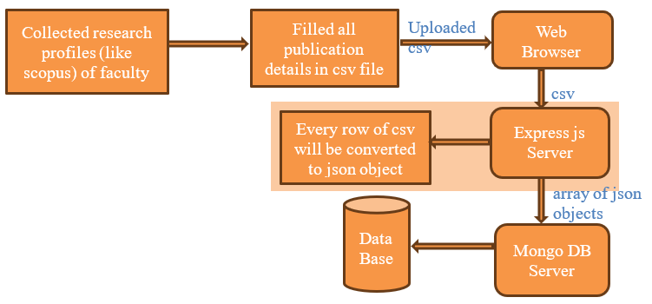

**3.6 Methodology for Publication Retrieval**

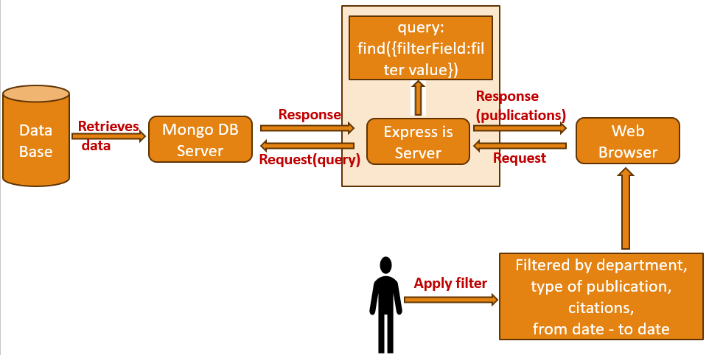



**3.7 Software Requirements:**

Operating System : Windows 8GB RAM or above

Server Side Script : JavaScript

Programming Language : JavaScript

Libraries : Express,axios,mongoose,react-icons etc

IDE/WorkBench : Visual studio code

Technology : Mern Stack (MongoDB,ExpressJS,Reactjs,Nodejs)

Database : MongoDB

**3.8 Hardware Requirements:**

Operating system: Windows

Processor : intel i5

RAM :8GB or Above

**CHAPTER 4**

**DESIGN**

**4.1 Introduction of Input Design:**

It courses as the doorway of system to users interactions therefore input design is a core part of any information system. Therefore, users should be attended to by means of forms, displays and interfaces in order for the system to accept data and communicate with them. The input design of a UI should be designed in such a way that users can enter data correctly, securely, and promptly, as well as intuitively. Meanwhile, within the framework of our educational project, the input design is extremely important in order to make the appearance of the research resources and input of study abstracts easy and to communicate with the system.

**4.1.1Objectives for Input Design:**

1. **User-Friendly Interface:** Input design out philosophy is a creation of an interface which is user-friendly for his communication with the system for input of data. To fulfill this, the form designers have to devise easy-to-use forms and interfaces, which does not block the user from plainly and easily giving the required information.
2. **Data Accuracy:** The further new target is getting data accuracy, which is the other important goal. Since input data errors and data corruptions may happen frequently, a validation strategy and error control procedures need to be initiated in input architecture.
3. **Efficiency:** It supports to design an optimal input for efficiency purpose. Users’ data input should be quick and easy, consequently, eliminating both time and effort consumption when searching for the research resources or for a study abstract writing.
4. **Compatibility:** In order to take care of the group of users with different requirements, the input design has to be developed in a way to be compatible with not only one particular device, for example, desktop computers, etc. but also with the next devices such as mobile phones or tablets.

**4.1.2 Introduction to Output Design:**

The primary focus of theusers interface interaction is transmission of system information and results. Such is paramount in making sure the given information is shown in a way that easy to comprehend and even meaningful. Showing the search result, data analysis, and generally any information which concerns these functions of the system, which depends on the output form for the project’s context. An optimal output experience for both learning and researching purposes is the main focus behind producing clear, visually pleasing, and most importantly useful information.

**4.1.3Objectives for Output Design:**

**1. Readability and Clarity:** Legibility is the most important aim of any output design. Thus its content should be produced in a hassle-free and readable way. The system should be supported by a friendly interface that will allow the data to be clearly understood and used by the users.

**2. Relevance:** Relevance of substantial information is most importantly, in the case of an output designing.It seeks to guarantee that users obtain information and understandings that are directly pertinent to their goals and areas of interest in research.

3 **.Visual Appeal:** To make the output visually appealing and make it easier for users to understand complex information, visual components like charts, graphs, and data abelledion should be employed.

**4.Customization:** Users should be able to arrange and abelled data in a way that best fits their preferences and research requirements by having some degree of control over the output from the system.

**4.2 UML Diagram:**

**4.2.1 Use-Case-Diagram:**

A use case diagram is a json a behavior diagram that shows the functional requirements of a system and json the diagram of its interactions with users and other actors (external systems). It is beneficial to show the different scenarios or tasks that a system is capable of carrying out and how they connect to users or other external entities.

This use-case diagram, as displayed in fig. 4..1, describes the interactions that take place between different actors and the system, specifying their interactions and the particular tasks they are able to carry out. These details provide further details about the characters and their roles in the context you indicated, which seems to be connected to a website:

**Users:** One of the main actors in the use case diagram of a website is the user. They stand for people who use the website for a variety of reasons. Users can be students, researchers, readers, or clients respectively of any website depending on their purpose. Three cases for example: “Content Browsing,” “Information Searching,” “Account Registration,” “Account Logging In,” and “Feedback Providing.”

**Authors:** The editors of the website are the ones that produces the videos. They are the so called authors. These particular people contribute content to the site, such as articles, news posts, and other content types. A writer can invent examples of using cases such as “making content, editing posts, publishing articles, and dealing with the user comments.”

**Administrators:** They are key in holding the website together and the management of its maintenance. They can be used to create and set up user accounts, to monitor or control shared content such as documents and files, to provide security to the data, and to handle technical issues. This role envisages responsibility like “Content Moderation,” “User Account Management,” “Security Configuration,” and “Database Maintenance.”

Website: The website is put into a certain role for the purpose of some of the use case diagrams as an actor. It might not be a full-fledged actor within the system which it serves, but it can be viewed as the heart and engine of that system acting as a hub for other actors that interact and contribute to the overall performance of the system. Use cases for the website would include essential features like “feedback collection,” “user registration,” “search functionality,” and “content delivery.”

Use case diagrams are a valuable tool for comprehending the functioning of a system and verifying that user demands and system requirements are clearly stated and fulfilled. They offer a clear visual depiction of the roles and interactions inside a system.

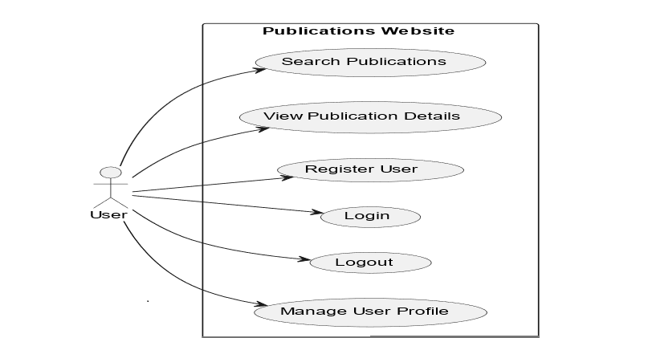

Fig-4.2.1..1 Use_Case Diagram for users

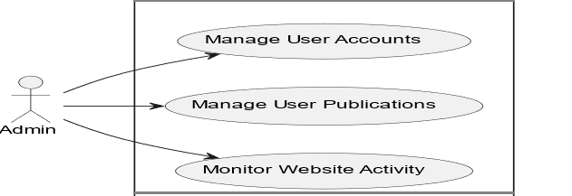

Fig-4.2.1.2 Use_Case Diagram for Admin

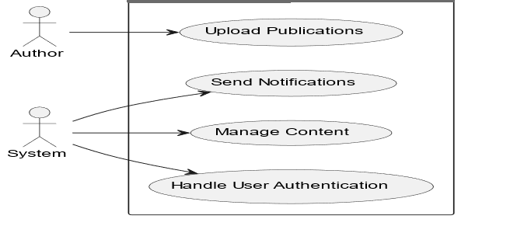

Fig-4.2.1.3 Use_case Diagram for Authors

* + 1. **Class_Diagram:**
* A class diagram is a type of Unified Modeling Language (UML) diagram; it describes the structure and organization of a system or software program, is displayed in Figure 4.2 It is an essential tool for building and modelling object-oriented systems because it gives a visual representation of the classes, objects, connections, and attributes inside a system.
* A system’s or software application’s structure and abelledion are represented by a class diagram.
* By using class diagrams, design of a system depicts the classes that make up the system and their properties, functions and the relationsships they have among their own classes.
* These are a few of the important courses.
* **User:** stands in for a website user.
* **Properties:** UserID, Username, Email;
* **Techniques:** Register(), Login(), Logout()
* **Publications**: Represents one of the website’s publications.
  + PublicationID, Title, Content, Author are among the attribute.
  + Display() and CommentOn() are the methods.

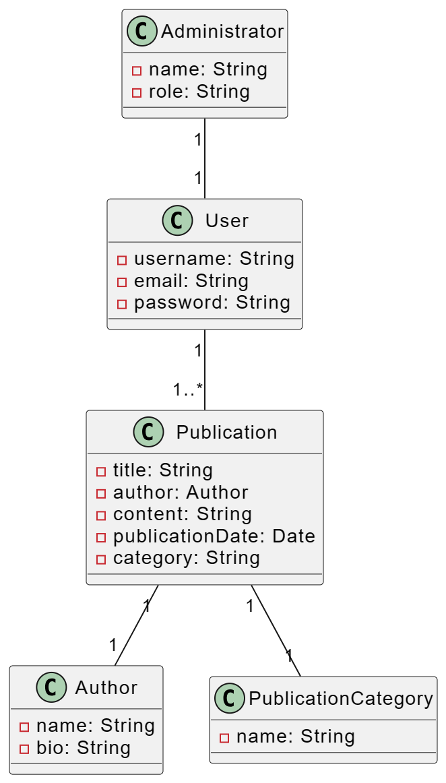

Fig 4.2.2 Class_Diagram

* + 1. **Sequence_Diagram:**

Sequence diagrams are classified as logical representation following the behavior of actors and objects and the messages passed within the system. It allows you to have a wealthy and interesting overview of the components relationships which make up a system, show you how they do the function that is related to the task and the case.

▪ Having the sequence diagram allows for showing relationships within the system or objects of the system. The formulation can be done in the short run or the long run, based on the time frame that is provided.

▪ Sequence Diagram depicts the individual communication sequences over a fixed period of time between some objects and system elements.

* **Participants** :
* User
* Website (Controller)
* Server
* Database

Fig 4.2.3 Sequence_Diagram

* + 1. **Activity_Diagram:**

An activity diagram which is a UML variant is created to visualise and sequence events while bringing out the events workflow into operation, process or system development for the purpose of design perfectioning. We are informed that the method is an important one for modelling, analyzing, and communicating about all aspects, points, and stages of the process as well as in reaching a comprehensive view of all that.

An activity diagram essentially shows all the stages of a project or a system by depicting all of their parts .

It is especially helpful for visualising the workflow and processes within a system because it depicts the flow of actions, decisions, and activities within it.

Fig 4.2.4.1 Activity Diagram From Login to Logout

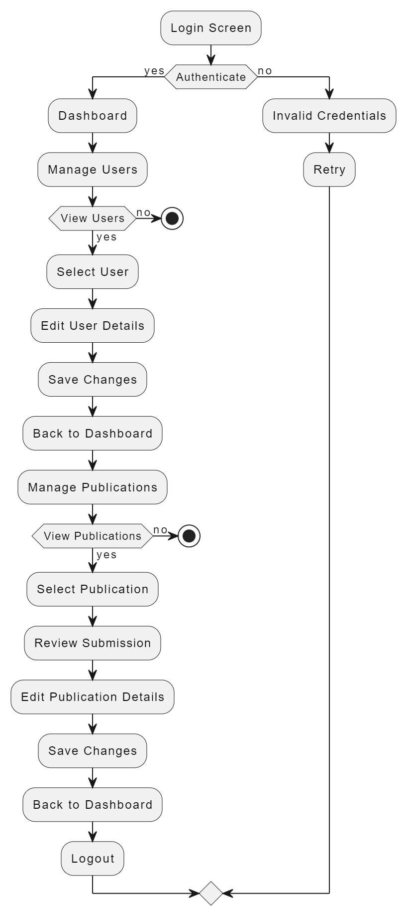

Fig 4.2.4.2Activity Diagram For Admin

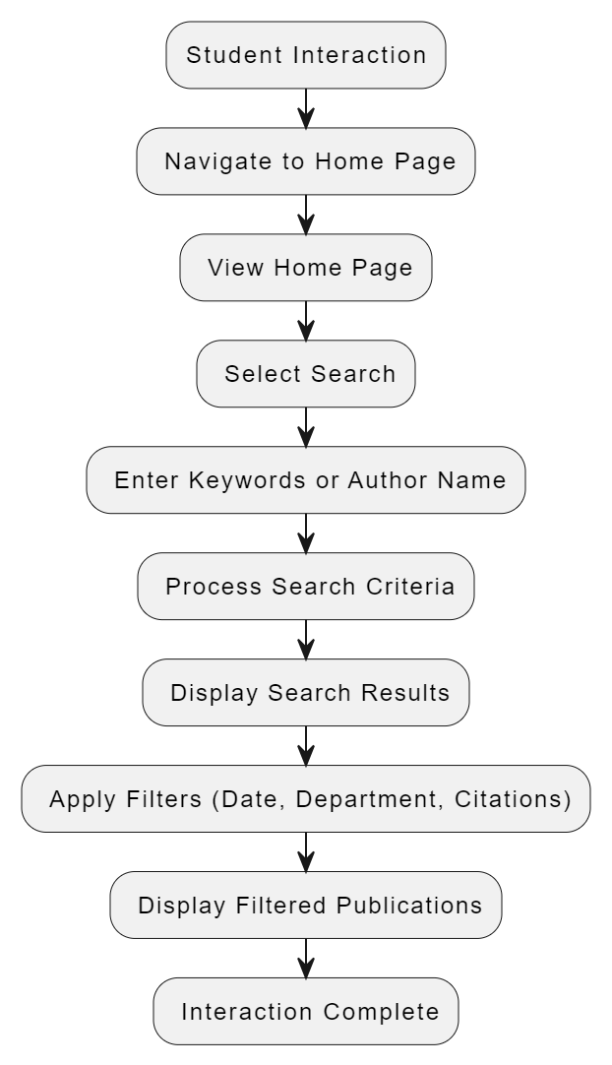

Fig-4.2.4.3 Activity_Diagram For Student

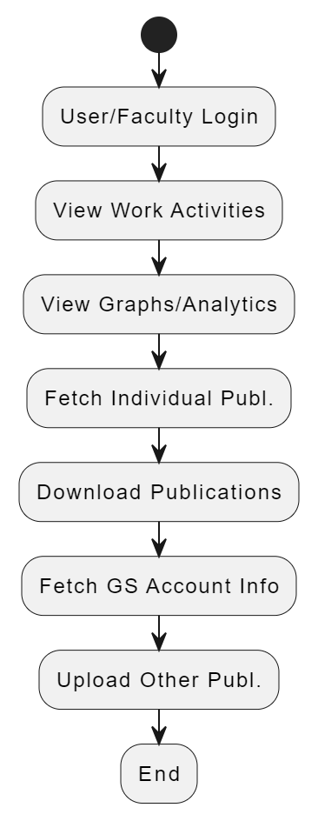

Fig-4.2.4.4 Activity_Diagram For User

**CHAPTER 5**

**IMPLEMENTATION**

**5.1 Dataset used:**

A wide range of documents, including book chapters, journals, conferences, and patents, are included in our dataset.

As shown in Figure 5.1.1, the government license or authorization that confers a title or right, usually for a specified period of time, in particular, the exclusive right of any third party to keep it from making, using, or selling its creation.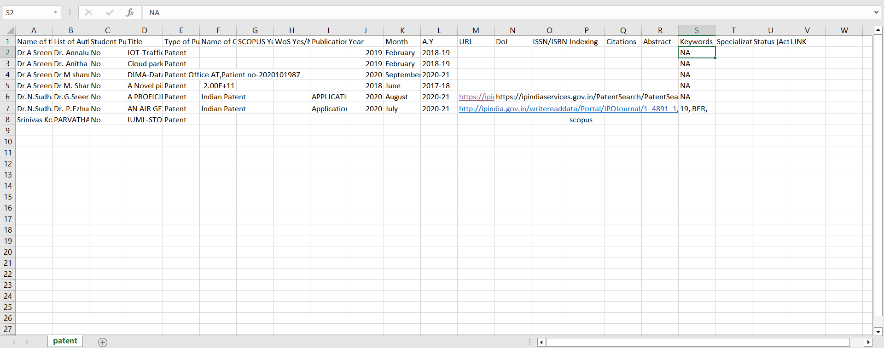

Fig 5.1 Patents

**Journals:**

As shown in fig 5.1.2 newspaper or magazine that deals with a particular subject or professional activity.

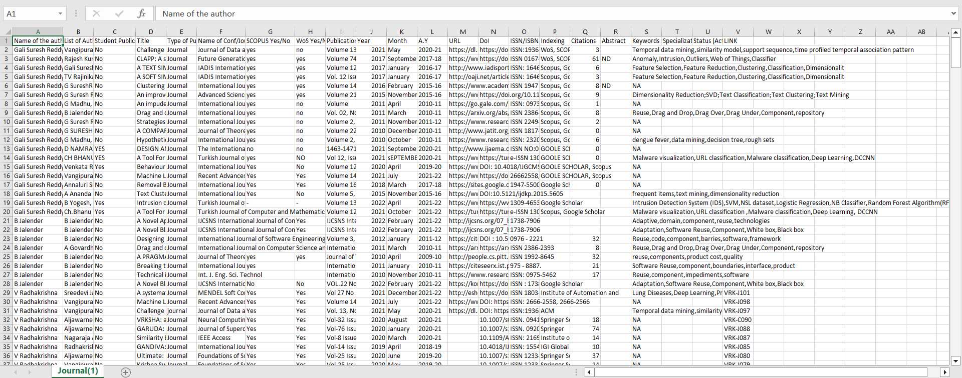

Fig 5.2 Journals

**Conferences:**

As shown in fig 5.1.3: a formal meeting of people with a shared interest, typically lasting severaldays.

Fig 5.3 _Conferences

**Book Chapter:**

Chapter Shown in a Book Chunk, Point 5.1.4 A section of the book that ends with a recognizable ending, usually clearly marked by either a page break or an extra space before the next chapter, which may be numbered and/or titled.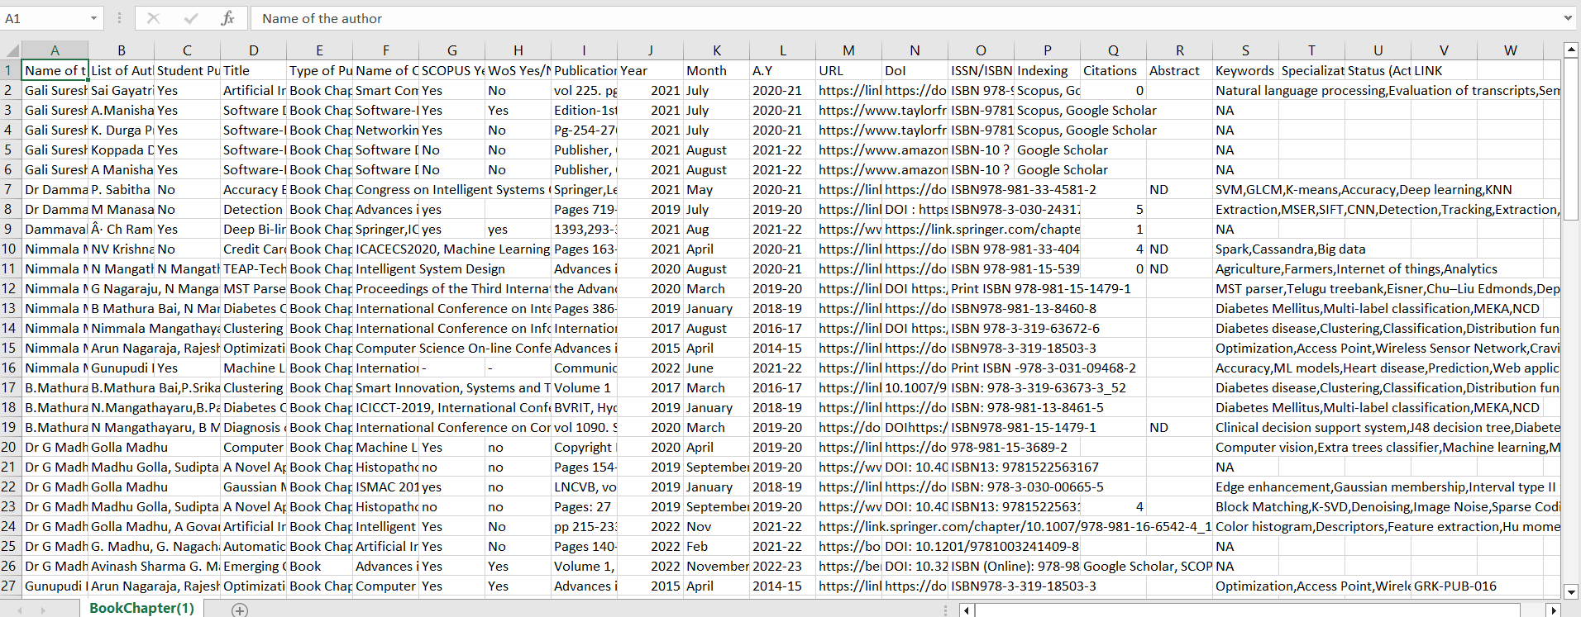

Fig 5.4 Book Chapters

* 1. **Experimental setup:**

Analytics:

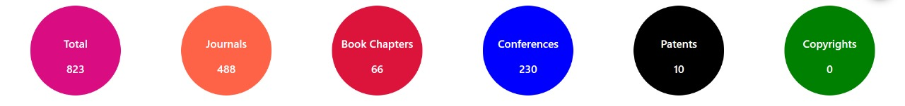

Fig 5.1

Fig 5.1 Shows the analytics about total number of publications and category of the publication and number of publications in each category

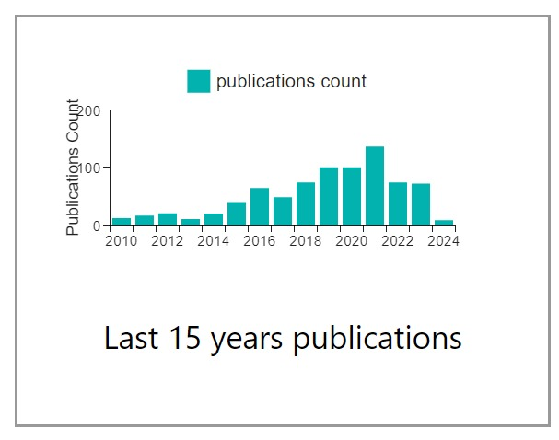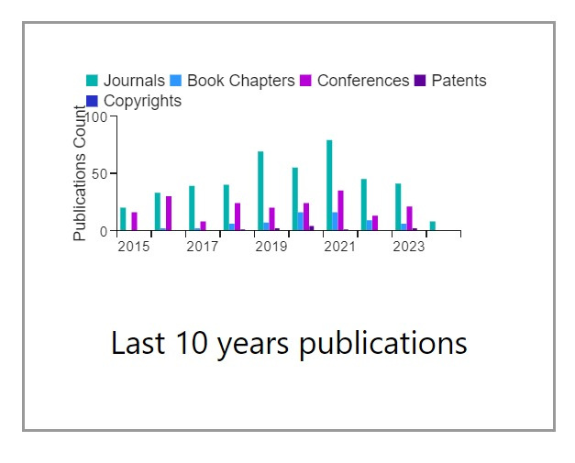

Fig 5.1.1 Fig 5.1.2

Figure 5.1.1 and figure 5.1.2 displays last 15 years and 10 years analytics based on total count and category respectively.

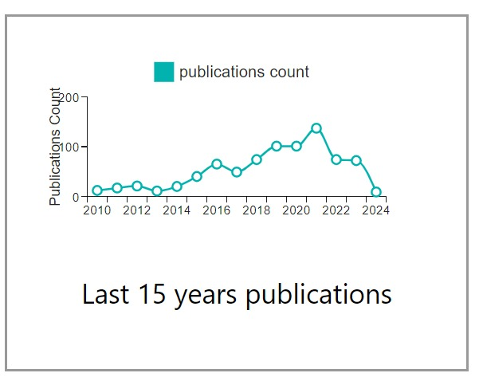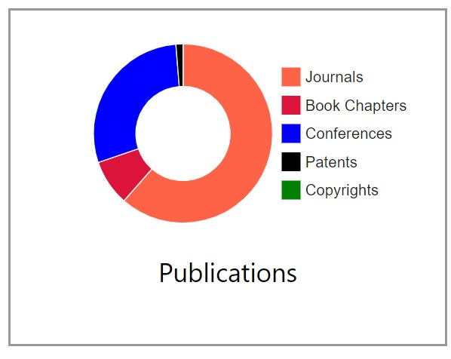

Fig 5.1.3 Fig 5.1.4

Figure 5.1.3 and figure 5.1.4 Illustrates the overall total number of publications and the publication count for the last 15 years using pie charts and line graph.

**Home Page:**

Fig 5.2 Home Page

Figure 5. 2 Illustrates the overall total number of publications and the publication count for the last 15 years using pie charts and bar graphs.

Fig 5.3 Home Page

Figure 5.3 showcases publications spanning the last 10 to 15 years and includes a navigation menu which provides user to navigate through the department.

Fig 5.4 Home Page

In Figure 5.4, there are 20 publications displayed. If the user wants to view more, they can click on the ‘ShowMore’ button, it is redirected to login page.

Fig 5.5 Login Page

In Figure 5.5, users can access additional publications by verifying their email and password.

Fig 5.6 Admin Dashboard

Upon successful login with valid credentials, the Admin account will be authenticated, and a summary of the user’s details and activities from the past 15 years will be displayed as showed in figure 5.6.

Fig 5.6.1 Upload new option

By Clicking on “Upload new “,admin can upload images to carousel ,can download and upload csv file figure 5.6.1.

Fig 5.6.2 Deleting publications

Admin can delete the publications all at once or selectively as shown in

figure 5.6.2.

Fig 5.6.3 User Profile

Alert box is shown to confirm delete as shown in figure 5.6.3.

Fig 5.6.4 Edit Page

Figure 5.6.4 shows edit page in which all the required fields are displayed and gives access to edit the content.

Fig 5.6.5 Edit Page

Figure 5.6.5 shows edit page in which all the required fields are displayed and gives access to edit the content.

Fig 5.7 User Profile

Upon successful login with valid credentials, the user account will be authenticated, and a summary of the user’s details and activities from the past 15 years will be displayed as showed in figure 5.7.

Fig 5.8 User Activity for past 15 years

The chart in Figure 5.8 provides an overview of user details, including their total number of publications, citations, and a 15-year count.

Fig 5.9 User Research Activity corresponding to sites Links.

Figure 5.9 displays various site links for users to access. By clicking on these links, users will be redirected to the respective sites. Additionally, the user’s educational details are presented below.

Fig 5.10 Can update, download, and upload Publications.

The diagram abelled 5.10 shows that users have the option to update, download, and upload publications by clicking on the corresponding buttons.

Fig 5.11 Can update, download and upload Publications.

As Shown in figure 5.11, By clicking the FetchGS button, the system updates the total number of publications through web scraping.

Fig 5.12 Can upload Publications.

Users can upload publications by clicking the upload button. They should download the provided template CSV file, fill it out, and then upload the completed CSV file. 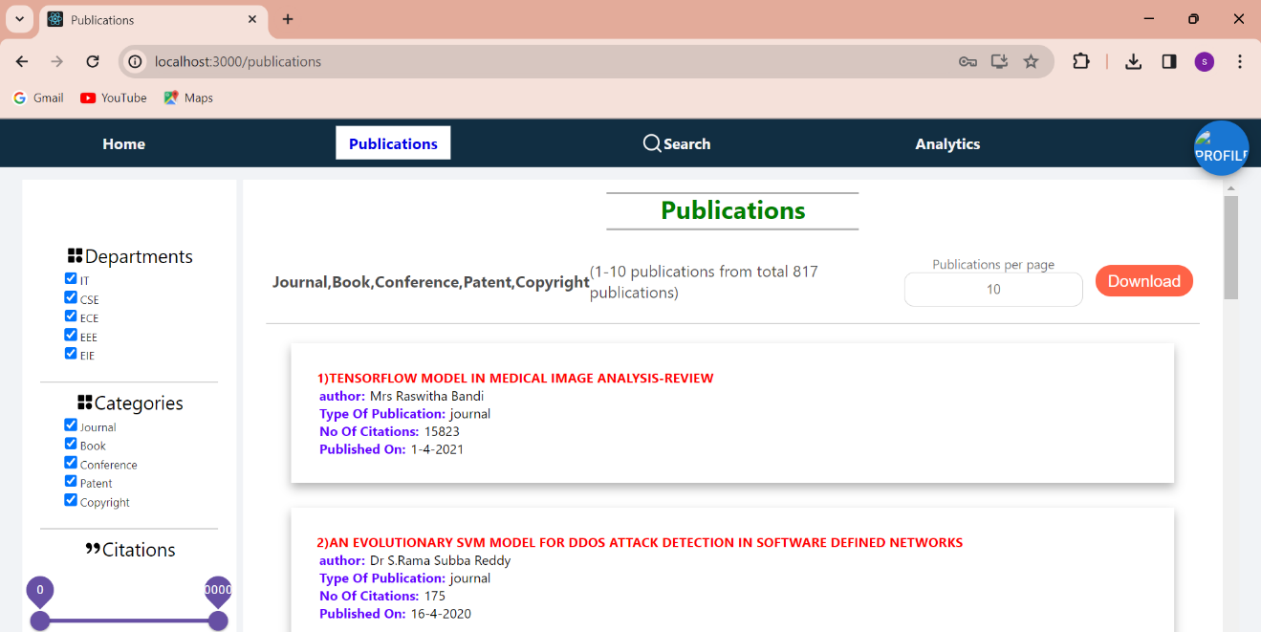+

Fig 5.13 Publications Page.

Figure 5.13 illustrates the total number of publications. Users have the option to download these publications.

Fig 5.14 Publications Page.

Figure 5.14 illustrates the total number of publications. Users have the option to download these publications.

Fig 5.15 Publications Page.

Figure 5.15 illustrates the total number of publications. Users have the option to download these publications

Fig 5.16 Publications Page.

In Figure 5.16, users have the option to apply filters by interacting with checkboxes, drag bars, or date filters. When they click the apply button, the selected filter is applied, and relevant publications are shown. 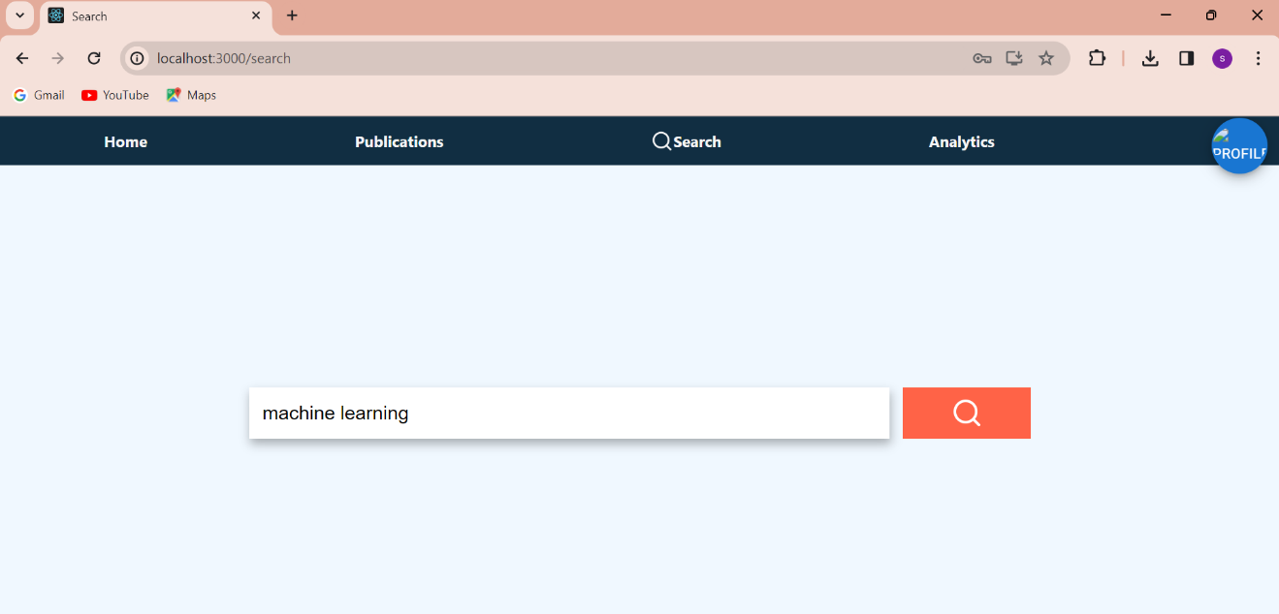

Fig 5.17 Search Page.

The user has the option to search by entering keywords or an abstract, as demonstrated in Figure 5.17.

**Document search using NLP:**

1. **Index Creation:**
   * Define which fields to index (e.g., keywords, abstract, title).
   * Specifies how data should be analyzed during search operations.
2. **Data Ingestion:**
   * Deploy documents onto the database after index creation.
3. **Query Parsing:**
   * User queries sent to the database using $search query operator.
   * Search parses the query to understand user intent, breaking it into tokens and identifying keywords.
4. **NLP Processing:**
   * The techniques will include tokenization, lemmatization, part-of-speech tagging, NER, sentiment analysis.
5. **Query Execution:**
   * Executes search operation against indexed fields and documents.
   * Utilizes search algorithms like inverted indexes and TF-IDF.
6. **Presentation of Results:**
   * Results returned to the website’s backend server and then to frontend for display.

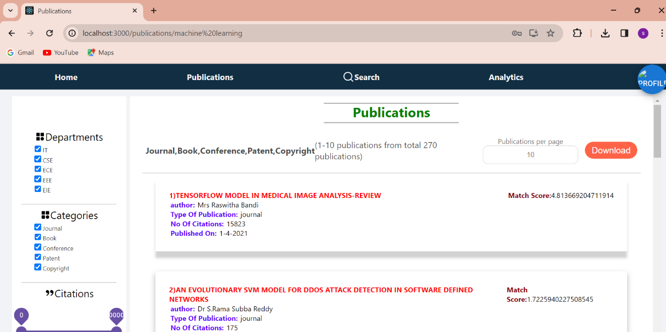

Fig 5.18 search page result

The results are generated and displayed on the screen based on the provided keywords or abstract, as shown in Figure 5.18.

Fig 5.19 Account Logout.

When the user clicks on the logout button, they will be logged out of their account as shown in the figure 5.19.

**CHAPTER 6**

**CONCLUSION**

To sum up, our project marks a significant advancement in the field of academia as we set out on a revolutionary quest to improve the efficacy and efficiency of research material management for academic researchers and college instructors. This project is our answer to the issues presented by the unparalleled era of information dissemination that the modern era has ushered in. We are dedicated to using cutting-edge technology, such as HTML, CSS, JavaScript, ReactJS, MongoDB, and ExpressJS, since we want to provide academics with a cutting-edge tool that makes organising, finding, and retrieving research materials more efficient.

Fundamentally, the goal of this application is to completely transform the way that research resources are accessed by making them simply accessible and discoverable. Users may easily explore a multitude of academic resources with keyword-based and advanced search options, cutting down on search time and improving the effectiveness of their research projects. Moreover, it provides a personalized research experience using NLP and ML algorithms to recommend to users only what would fit well in the context of their distinctive study goals. User-provided search entries will be highly accurate and contextually aware—serving both keyword-based and abstract-based searches together through our system, leveraging the latest in Machine Learning (ML) techniques and corresponding Natural Language Processing (NLP) capabilities.

Beyond the efficiency benefits, our project aims to use data analytics to give academic institutions a complete picture of faculty research activity, enabling them to make well-informed decisions. We place a high priority on having an intuitive and responsive user interface so that users can easily access the programme on many platforms and that strong data security is maintained to protect confidential research materials.

In addition, we understand that continuous user education, assistance, and a sustainability strategy are critical to guaranteeing the application’s durability and flexibility. This project is a major achievement at the nexus of technology and academia, not just a technological integration. It has the potential to increase research process productivity and efficacy, making it easier for academics and college instructors to move about the academic environment. As we go, our dedication to enabling academia with a technologically advanced, dynamic solution that maximises the potential of research materials and cultivates a culture of research excellence and knowledge progress does not waver.

**CHAPTER 7**

**FUTURE ENHANCEMENT**

We anticipate a state-of-the-art interface in the future that will seamlessly and effortlessly provide article searches, successfully addressing the shortcomings of the current system. By utilising the latest Machine_Learning (ML) techniques along with Natural_Language Processing (NLP) capabilities, our system will provide users with extremely precise and context-aware keyword-based and abstract-based searches, hence improving their overall experience. Future improvements will centre on sophisticated data visualisations, utilising machine learning algorithms to produce informative and interactive data representations, in addition to effective searching. These improvements will encourage a culture of research excellence and knowledge progress in the academic community by enabling users to easily locate research resources and to have a deeper grasp of the academic environment through dynamic and personalised data analytics.

Web Browser

**Request**

**Response**

**CHAPTER 8**

**References**

1. Natural language processing (almost) from scratch ronan r. k. ando and t. zhang. a framework for learning predictive structures from multiple tasks and unlabeled data. jmlr, 6:1817–1953, 11 2005.
2. Ben Wellner, The Mitre Corporation 202 Burlington Road Bedford ,MA USA.
3. Hinton, G.E.; Osindero, S.; The, Y.W. A fast-learning algorithm for deep belief nets. *Neural Comput.* 2006, *18*, 1527–1554.
4. James Pustejovsky ,Department of computer science,Brandeis University Waltham ,MA USA
5. Vidwan Website-The display of the user publications and the graphs representations.
6. www.scopus.com,www.googlescholar.com,www.webofsciences.com-Publication details.
7. Mohammad Zahid Mohammad Sabri,Siti Aishah Hanawi.Prediction Model based on Continuous Data for Student Performance using Principal Component Analysis and Support Vector Machine,
8. Holger Dette, Andrey Pepelyshev & Anatoly Zhigljavsky. Prediction in regression models with continuous observations
9. George Hripcsak and David J. Albers. Evaluating Prediction of Continuous Clinical Values: A Glucose Case Study
10. Sonali Antad, Saloni Khandelwal, Anushka Khandelwal. Stock Price Prediction Website Using Linear Regression - A Machine Learning Algorithm
11. Marti A. Hearst, Anna Divoli, Harendra Guturu, Alex Ksikes, Preslav Nakov. BioText Search Engine: beyond abstract search
12. MJ Cafarella, O Etzioni. A search engine for natural language applications
13. DS Sirisuriya - 2015,A comparative study on web scraping
14. R Lawson - 2015, Web scraping with Python
15. W Duch - Feature extraction: foundations and applications, 2006 - Springer:Filter methods
16. The use of Markov model in continuous time for prediction of rainfall for crop production,UY Abubakar, L Adamu, M Abdullahi
17. J Clark - 2001.Building accessible websites
18. M Boardman.The language of websites

**SHOW AND TELL**

**Major Project Team A-13**